 | 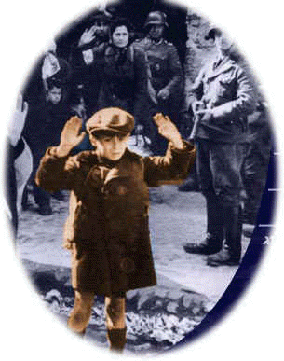  I.  I would like to be an artist  So I could make a Painting of you  Little Polish Boy  Standing with your Little hat on your head  The Star of David on your coat  Standing in the ghetto with your arms up as many Nazi machine guns pointing at you  I would make a monument of you and the world who said nothing  I would like to be a composer so I could write a concerto of you  Little Polish Boy  Standing with your Little hat on your head  The Star of David on your coat Standing in the ghetto with your arms up as many Nazi machine guns pointing at you  I would write a concerto of you and the world who said nothing  . | II.  I am not an artist  But my mind had painted  a painting of you  Ten Million Miles High is the Painting  so the whole universe can see you Now  Little Polish Boy  Standing with your Little hat  on your head  The Star of David  on your coat  Standing in the ghetto with your arms up  as many Nazi machine guns pointing at you  And the World who said nothing  I'll make this painting so bright  that it will blind the eyes  of the world who saw nothing  Ten billion miles high will be the monument  so the whole universe can remember of you  Little Polish Boy  Standing with your Little hat  on your head  The Star of David  on your coat  . | III.  Standing in the ghetto  with your arms up  as many Nazi machine guns pointing at you  And the monument will tremble so the blind world  Now will know  What fear is in the darkness  The world  Who said nothing  I am not a composer  but I will write a composition  for five trillion trumpets  so it will blast the ear drums  of this world  The world's  Who heard nothing  I  am  Sorry  that  It was you  and  Not me

