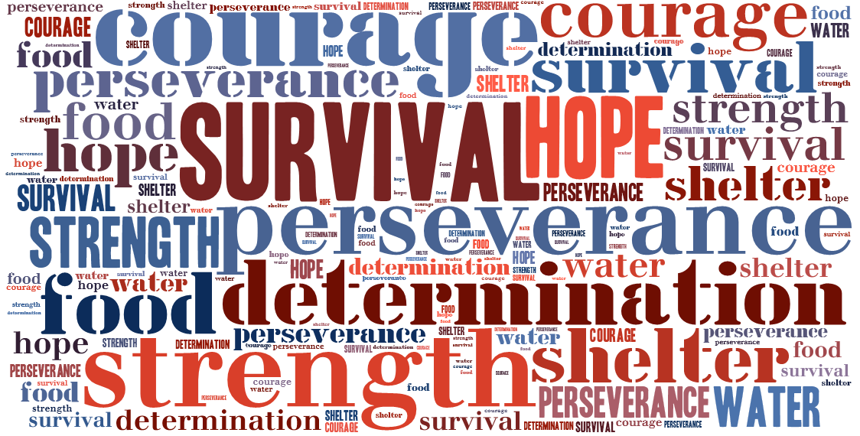

You have discovered another incredible story of humans who have survived the impossible. Now, you need to share their story with others. You will create a Google Slide presentation that includes one slide for each of the following:

- Title slide: Name of Article and Names of Group Members
- Summary Slide: A brief description of the events that the person/people endured.
- Signpost slides (5-6)
  - Photos/ Graphics: Include the images in the presentation by searching for them on Google
  - Definitions / Statistics: Include definitions of words that would be important for your audience to understand (if applicable) and any statistics that were mentioned in your article.
  - Cause and Result: What caused the survival situation and what were the results?
  - Tough Questions: And answers to the questions
  - Memory Moments / Anecdotes: any brief stories that contribute to the article.
  - Contrasts/ Contradictions/ Comparisons: If your article included any of these, then provide an explanation of them for your audience.

You will need to divide up the work evenly amongst your group members, but remember, ALL OF THE COMPONENTS MUST BE INCLUDED REGARDLESS OF HOW MANY PEOPLE ARE IN YOUR GROUP.

Provide the group role assignments here:

Group Member Name Slide Created

