“Romeo and Juliet “Greeting Card”

Directions: Based on “Romeo and Juliet”, create a greeting card that represents the tone shift of the Romeo’s feelings toward Rosaline, or Juliet’s feelings about marrying Paris. On the front of the greeting card, display a picture and a corresponding sentence that matches the character’s feelings (or tone) initially. Then, on the inside of the greeting card, show the tone shift by displaying a picture and a corresponding sentence that matches the change in tone that occurs after Romeo and fall in love.

It will be up to you to be creative, inventive, and imaginative when working on the visual display of the greeting card. You will need to be resourceful by using your own interpretation of the play to the showcase the tone shifts. Be sure to revise and edit your card for spelling and grammar.

On the front of the greeting card, you must include the following:

- An image that displays the “nice” tone.

- A sentence corresponding to the tone in which you are trying to display.

Front of the greeting card: This example displays a POSITIVE tone that expresses the supposed friendship and admiration Montressor had for Fortunado.

Example for “The Cask of Amontillado”
FORTUNADO, I WANT TO MAKE A TOAST TO A LONG LIFE, HEALTH, AND HAPPINESS!
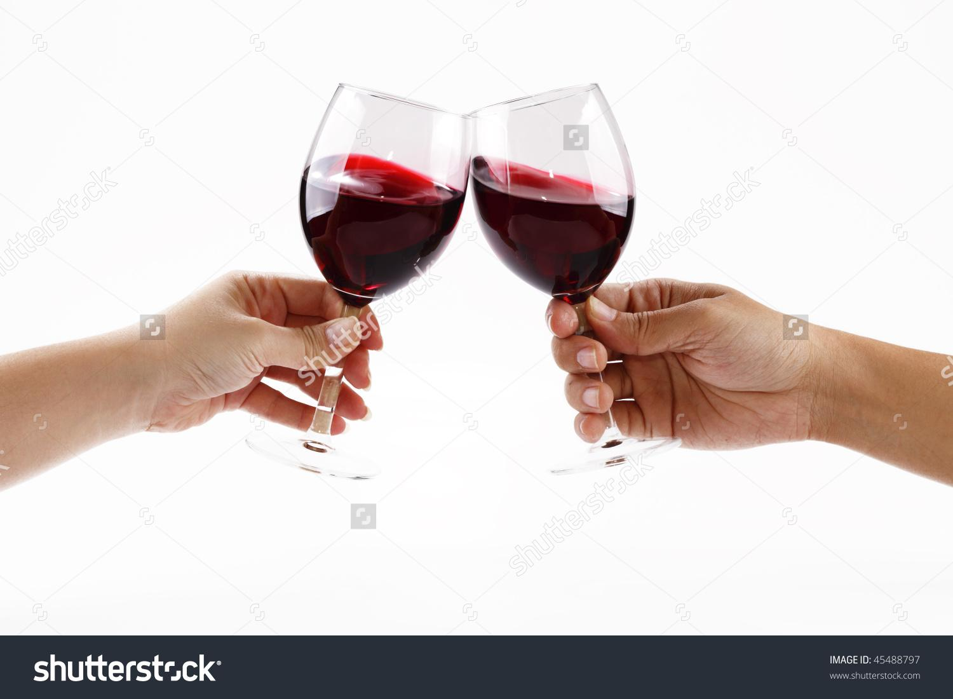

On the inside of the greeting card, you must include the following:

- An image of the changed feelings/ not so nice tone.

- A sentence corresponding to the tone shift in which you are trying to display.
Inside of the greeting card: Since the front of the card is positive, the inside of the card shows tone shift by changing the connotation of words and the pictures to display a NEGATIVE tone.

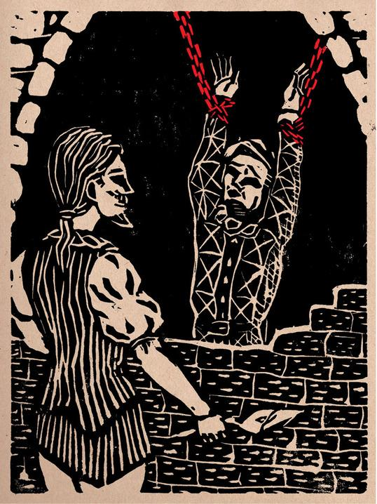
THE ONLY PROBLEM IS, I WANT TO GET MY REVENGE ON YOU FOR INSULTING ME!

Complete a draft of your greeting card here:

Front Back

Rubric

1. Does the front of you card successfully create one specific tone with the use of an image and corresponding sentence?

25 30 33.4

2. Does the inside of your card successfully show tone shift with image and corresponding sentence?

25 30 33.4

3. Does your card show understanding of the characters, plot, and/or theme of the play. Is your card aesthetically pleasing, does it show time and effort put into you r work.

25 30 33.2 Total Points Earned _________________________

