READ-IN BOOK
REVIEW/PROMO FLIER

Now that you have an idea regarding what your chosen book is about, you will use that knowledge to complete a book review / promotional flier for your chosen piece of literature. The flier will be created on smore.com, and must contain the following required components:

- In the next “section”, write a summary of the story including
- plot,
-character(s),
-conflict,The top of the flier must include: Title, author, and image of the book, and a one-line “hook” about the main idea of the story. THIS MUST BE IN YOUR OWN WORDS BASED ON WHAT YOU READ.

- theme.
- For the next section, you will write an explanation of why you would recommend this book to others. You MUST answer the following three questions:
1.Why did you choose this book?
2.Who would enjoy this book (think age group)?
3. Why is it a good read?
- “Suggested reads” - 3 suggested literary works based on the book you selected. Use bookseer.com to find suggested reads for people who may have read and enjoyed your selected story. You must also include the title, author, a summary, and an image of each suggested book, along with a citation for the source from where you obtain the book summary.

TO SUBMIT YOUR ASSIGNMENT, FOLLOW THE DIRECTIONS CAREFULLY: Once you have created your flier, click the shareable link in the box on the right side of the screen and copy it. Paste it into a new google doc in your google drive in the folder for your English 1 assignments.
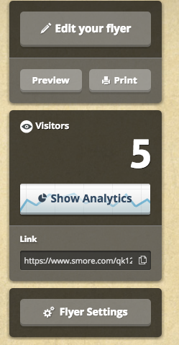

Here is a sample of what your flier should look like:
