Nonfiction Articles Comparison Chart Using Signposts

 | “Child migrants to U.S.” | “Wrath of ‘neo-Nazis’” | “Refugee children …without parents” | “A home lost, a home found”
What is the problem?

What caused the problem? Result?
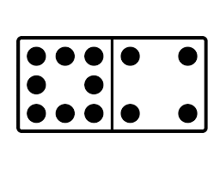
Who is affected?
What “solution” has been implemented?

List and define relevant terms or vocab.
Are there any photos/graphs that contribute to the article?
How does the information in this article make you feel?
How do you think the US should respond?
How does this article relate thematically to Night? (What similarities are there?

