How to Write a Dystopian Short Story
Adapted from the original composition BY NAFIZA

The Dystopian story made easy.

Just follow these instructions and you will end up with a fantastic dystopian story too!

First, you take the world:

And break it:
Once you’ve messed it up enough that the natural resources have been completely depleted and danger is everywhere, find a small group of surviving mankind and place them in a controlled setting.
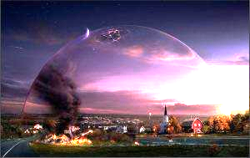

Determine your world’s name.

What disaster has happened to your world that caused it to become dystopian? (Natural disaster, human race overthrow, war, virus, etc.)

But, ensure that there is something terribly wrong with this dystopian society. For example, in the picture, the dome is cracking. In your story you could, umm… make love forbidden, or make monkeys rule, and since monkeys can’t rule very well (no offense intended), chaos would threaten which would mean that there is a necessity for heroes…

Create a hero, or group of heroes, that is the only hope for your world’s survival:

Suggestions for heroes: Remember to keep it interesting. There is always a struggle, or conflict, that the hero goes through, internal or external. What do they look like? Who was this person before the disaster? Why are they qualified to save the world? How will they survive?

Add the suspense factor: Will the heroine die from frostbite before the final book?

You could let the boy hero and girl hero fall in love. If there’s not much else going on, and you want to up the ante, maybe add in a love triangle (always makes for more tense moment, you know, her life may be over in the next few days but will she choose JOHN or DAVID?!? Wait for book 9 to reveal all!):

Of equal importance is a villain. Create one… Or two:
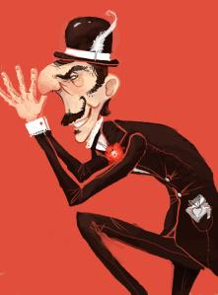

- What does you villain look like?
- What is his background story that created this evil being?
- Why does he want to destroy your hero/heroes?
- What is his goal for this world? Money? Power?

Have your villain have some sort of army:
- Soldiers: Your villain needs someone to do the dirty work. Create a type of army that carries out the villain’s wishes.

- Examples for villain armies:
- Zombies, future advanced soldiers, robots, vampires…etc.
Now that you have all these elements, bring them all together. There will be war over what??:

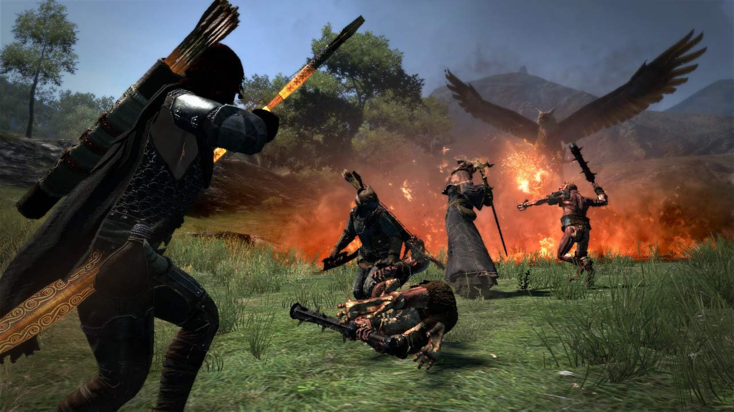
And your main characters will watch the world burn:
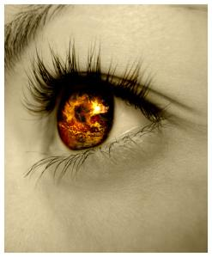
Make sure you don’t reveal who dies and who survives. You have to end the book on a cliffhanger so that people will stop breathing and (a year later) take another breath when they find out that your hero(s) survived. So you see, writing a dystopian story is very simple... As long as you follow these rules. Good luck. ;)

