MLA HEADING:

Analyzing an Argument – Romeo and Juliet

The following speech is from Act III scene iv of Romeo and Juliet. In grief and despair over his banishment, Romeo tries to stab himself, but the Nurse snatches the dagger from him. The Friar then says to Romeo:

Hold thy desperate hand:
Art thou a man? Thy form cries out thou art:
Thy tears are womanish; thy wild acts denote
The unreasonable fury of a beast:
Unseemly woman in a seeming man!
Or ill-beseeming beast in seeming both!
Thou hast amazed me: by my holy order,
I thought thy disposition better temper'd.
Hast thou slain Tybalt? Wilt thou slay thyself?
And stay thy lady too that lives in thee,
By doing damned hate upon thyself?
Why rail'st thou on thy birth, the heaven, and earth?
Since birth, and heaven, and earth, all three do meet
In thee at once; which thou at once wouldst lose.
Fie, fie, thou shamest thy shape, thy love, thy wit;
Which, like a usurer, abound'st in all,
And usest none in that true use indeed
Which should bedeck thy shape, thy love, thy wit:
Thy noble shape is but a form of wax,
Digressing from the valour of a man;
Thy dear love sworn but hollow perjury,
Killing that love which thou hast vow'd to cherish;
Thy wit, that ornament to shape and love,
Misshapen in the conduct of them both,
Like powder in a skitless soldier's flask,
Is set afire by thine own ignorance,
And thou dismember'd with thine own defence.
What, rouse thee, man! thy Juliet is alive,
For whose dear sake thou wast but lately dead;
There art thou happy: Tybalt would kill thee,
But thou slew'st Tybalt; there are thou happy too:
The law that threaten'd death becomes thy friend
And turns it to exile; there art thou happy:
A pack of blessings lights up upon thy back;
Happiness courts thee in her best array;
But, like a misbehaved and sullen wench,
Thou pout'st upon thy fortune and thy love:
Take heed, take heed, for such die miserable.

- Mark the rhetorical devices throughout the monologue:
  - Rhetorical question
  - Metaphor
  - Repetition
  - Personification
  - Simile (using “like” or “as”)

- Select three examples from number 1 above and write a paragraph (3-5 sentences) explaining how Shakespeare uses these rhetorical devices to create a speech that persuades Romeo to reconsider his irrational decision.

- Fill in the chart with examples of appeals to logic and appeals to emotion.
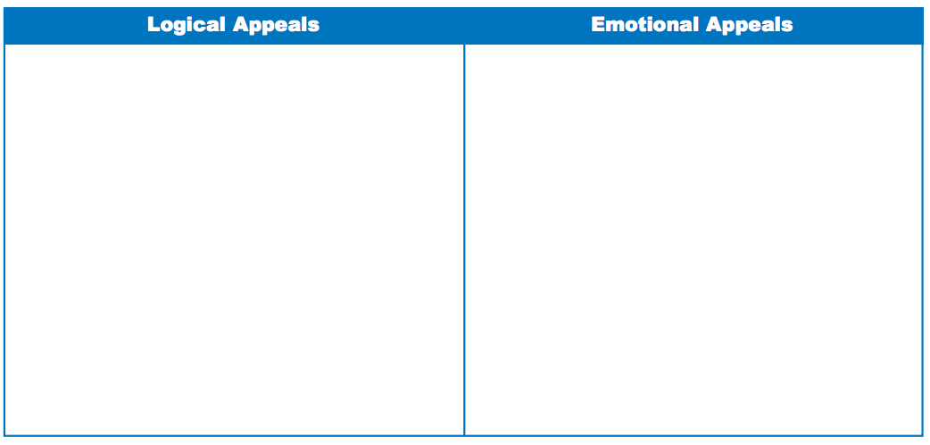
4. Does Friar Lawrence use more appeals to logic, more appeals to emotion, or is there a balance between the two? Explain how you determined this response.

