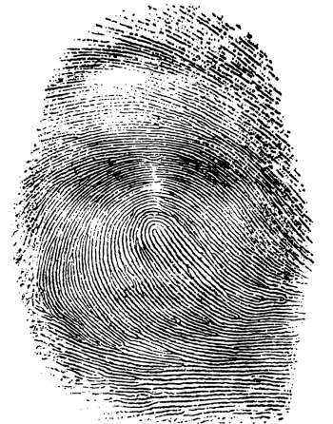
Autobiography Assignment:
Paired with Fiction Unit

The fictional dystopian stories we have been reading employ several strategies to build characters’ background and make them believable. In a similar way, you will add to your autobiography to build your own “background.” Revise ALL assignments before rewriting them in final form. Written components MUST be typed in MLA format. Remember to complete these assignments in your Google folder.

Complete the following autobiography components:

- These Words Belong to Me: Make a list of words that have special power and magic. Think of common words with uncommon meanings, or even strange new words that allow you to think a new kind of thought. For example, do you know what “serendipity” means? Find out why it’s so wonderful. What’s ironic about a “scar”? List and define at least TEN words. For each word, explain in at least two sentences why this particular word belongs to you; how it is a crucial part of your character.

- Personal Symbol: Write about an object that has special symbolic meaning for you. It might be a gift from someone you love, an award of which you are proud, a souvenir from a place you miss, a childhood toy you still treasure, a family photograph, whatever. Describe the object, appealing to the senses as appropriate and giving specific details. Also explain what it symbolizes for you. (½ a page - 1 page)

- One Medium Suitcase: Imagine you are leaving home forever, and you can only take what will fit in one medium-sized suitcase with you. Discuss at least FIVE specific items you will take with you and why. (1 page)

- The Perfect Present: Since I am the perfect teacher, I have the ability to select the perfect present for each of you. It’s something you’ve always wanted, something for which you’ve secretly yearned. It’s not a new phone or designer jeans because there’s a catch – the gift is intangible, or abstract. This means that you cannot perceive it with the five senses. For example, you might want patience, confidence, motivation. Tell me what the gift is, why it’s the perfect gift, why you need it, and how it will affect your life. (1 page)

Project Timeline:

Autobiography Components Assigned (Nonfiction Unit): Friday, October 30th
Autobiography Components Assigned (Fiction Unit): Friday, November 20th
THANKSGIVING BREAK: Monday, Nov. 23rd – Friday, Nov. 27th
ALL Autobiography Components DUE: Friday, December 11th

GRADING DISCLAIMER
Each component will be graded on a full, half, or no credit basis. That means you either fulfilled requirements, you attempted to fulfill the requirements, or you did not make an obvious attempt to fulfill the requirements.

